**16. A feladat a Rákosi-korszakhoz kapcsolódik.** (hosszú)

**Mutassa be a források és ismeretei segítségével a Rákosi-korszak gazdaságpolitikáját!**

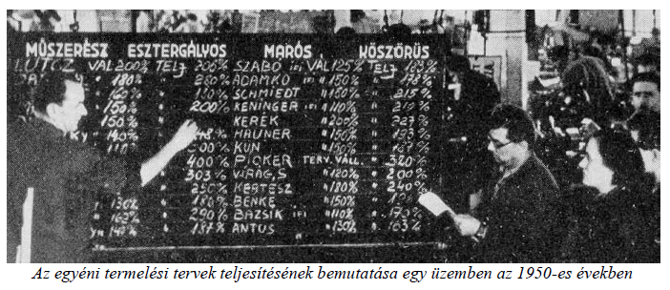

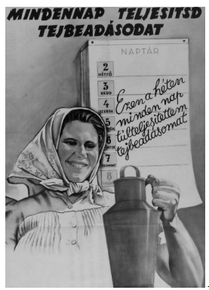*Propagandaplakát az 1950-es években*

